MAXDat Staging ETL Architecture

April 25, 2012
- Table of Contents
1. Table of Contents 2
2. Table of Figures 2
3. Introduction 2
4. Requirments 2
5. System Architecture 3
5.1. ETL Process Overview 3
5.2. Change Data Capture 4
5.3. Transformation 5
5.4. Jobs 5
6. Kettle Architecture 6

- Table of Figures

Figure 1 - MAXDat Staging ETL Process 3
Figure 2 - Change Data Capture Flow 4
Figure 3 – Jobs Process 6
Figure 4 – Pentaho Architecture 7
- Introduction
This document describes the architecture of the MAXDat ETL system from the OLTP product database to the Staging tables. This is not a description of the BPM portion of the MAXDat system.

The ETL tool that will be used for this element of MAXDat is Pentaho’s Kettle. Kettle is an open source tool specifically designed for ETL applications. Kettle provides a framework for the ETL needed on MAXDat. However, that framework will also constrain the design and may introduce some performance issues. So, designing the system to be as efficient as possible will be on of the main focuses of the system.
- Requirments
There are four requirements. One is that the data delivered to the BPM layer of the database from the Staging tables be done on a periodic basis in the range of every 15 to 30 minutes. So, all processes of extraction from the OLTP system(s) into all of the Staging tables should be completed within this time frame.

The second requirement is that the transformation portion of the ETL be rule based in order to allow the process of changes to be done quickly and by someone other than a high paid developer such as an analyst or less costly developer.

Next is the requirement that the system be database agnostic or not tied to any vendor’s technology, such as Oracle, Sybase, or Microsoft. This would preclude using specific vendor’s features, such as, PL/SQL for the ETL code.

Lastly, the system needs to be able to also process data from non-database derived databases, such as .CSV files, as well. Some of MAXIMUS’ telephony systems only produce data in the form of .CSV or even .HTML.
- System Architecture
This discussion of the MAXDat Staging architecture first needs an overview of the flow of data thru the ETL process (see Figure 1). The second section will describe the Kettle specific architecture.

Figure 1 - MAXDat Staging ETL Process

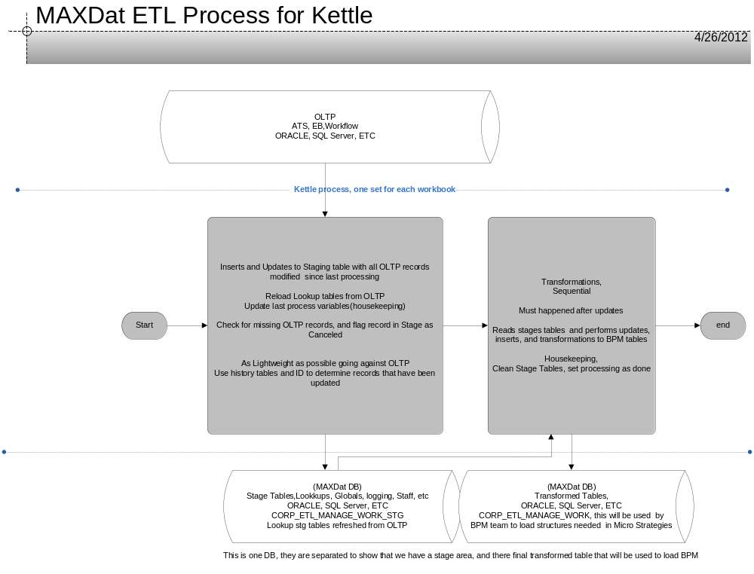

  - ETL Process Overview

The ETL process starts with the appropriate collection of data from the various systems of record, such as the ATS OLTP, Telephony ACD, or Imaging systems. These data maybe supplied by network connections, such as SQL*NET, ODBC, or Web, or they may be supplied in the form of files, such as .CSV files, such as IVR vendor reports.

There are two general types of data collected from the various systems of record. The first are the transaction data needed to monitor the business processes. This data changes frequently and is the relevant changed data.

The second set of data collected is slowly changing data. This data is needed for characterizing the transaction data. For instance, the business process needs to know who completed a task. The list of Staff members who may complete a task doesn’t change often and therefore is slowly changing. The system only needs to collect this type of data infrequently or when it changes.

Data needed for the transaction type of data is collected by Kettle. Each business process’ data will have a separate data collection process. For instance, Application Processing will have a data collection separate from say Process MI. Initially each data collection is run through a Change Data Capture process. The process determines which records are new, have been updated, or “Cancelled”. The collection process is designed to capture the minimum set of records needed so that down stream transformation and loading steps can finish in the required processing time.

  - Change Data Capture
Change data capture identifies records obtained from the OLTP database that are either new or have been changed. Because new records are processed differently than updated records in the Stage ETL, there needs to be this differentiation.

New data records from the OLTP database will not exist in the Stage table. For example, a Stage table contains data from the STEP_INSTANCE and STEP_INSTANCE_HISTORY records from the OLTP db. If the STEP_INSTANCE_ID, which identifies the task that is being worked, doesn’t exist in the Stage table then it is a new record. A new record in the Stage table is marked as New (See figure 2).

Changed records from the OLTP db are those records that have an existing record(s) in the Stage table. The records from the OLTP db are added to the Stage table and marked as updated (U).

Both the new and update records will have separate transformations processes. New records will be processed first and then update records will be processed.

Figure 2 - Change Data Capture Flow

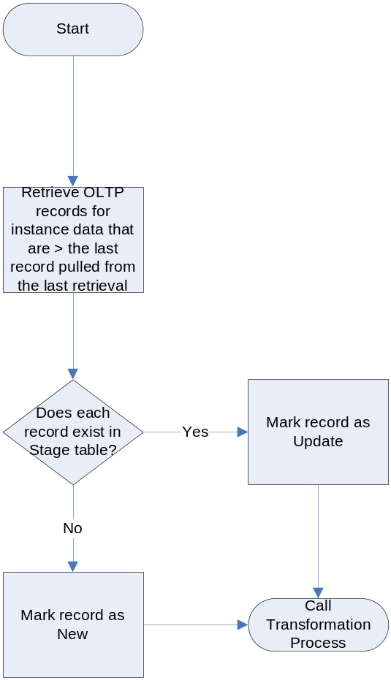

  - Transformation

After the data is collected and the appropriate change data capture category is determined, then the data is processed thru the transformation steps. Each data collection set will have a set of transforms that operate on each of the records collected. The rules for the transforms are maintained in the rules engine component within Kettle. This component is described in the next section.

  - Jobs
The ETL process will be initiated by cron on a periodic basis. This basis will be determined by each implementation based on reporting requirements. Typically this period will be in the range of 15 to 30 minutes.

The first

Figure 3 – Jobs Process
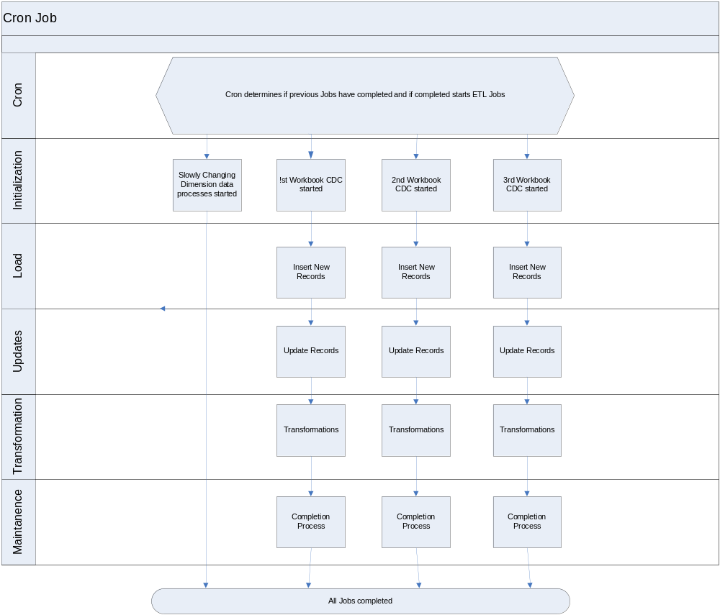

- Kettle Architecture

- Simple Rule Change: If a rule changes, then the specific transformation will require a change.
- Rule Changes that add or change output fields: These will require transformation changes and may require subsequent changes to calling transformation and or job to handle new fields
- Deleting Rules: These will require transformation changes and may require subsequent changes to calling transformation and or job to handle remove fields
- Adding Rules: These will require transformation changes and may require subsequent changes to calling transformation and or job to handle new fields

Figure 4 – Pentaho Architecture
